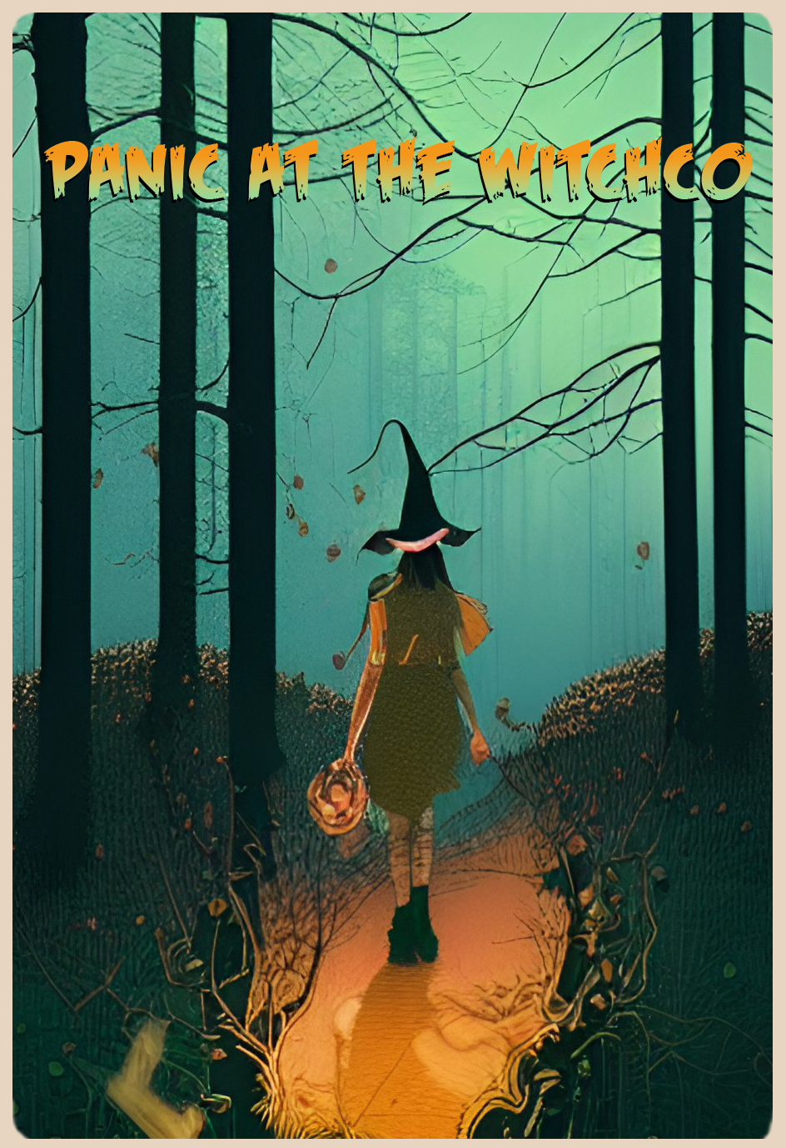

By: Lucy Coates

By: Lucy Coates

Table of Contents

# Contents

[Contents 2](#_Toc116138158)

[Story 3](#_Toc116138159)

[Reference 4](#_Toc116138160)

[Environment 4](#_Toc116138161)

[Setting 5](#_Toc116138162)

[Characters 6](#_Toc116138163)

[Features 7](#_Toc116138164)

[Style 8](#_Toc116138165)

[Program 9](#_Toc116138166)

[Rooms and features 9](#_Toc116138167)

# Story

* An idea for the story is the **witch Marigold Le Fae** whose **cabin sits at the bottom of a mountain**. The outside of the house looks like a beautiful cabin with a garden on the side meant to lure stray travelers in.
* The cabin features an area built into the mountain where the witch does her magic, a small alchemy lab, a library, and a hidden panic room if she gets attacked or her magic creations go out of control.
* The theme for this is a mix of fantasy with horror elements with a beautiful outside and a horrifying inside which represents the witches hidden area of her cabin.
* The witch uses souls of travelers to enchant and create golems and other magical creations as well as keep her young appearance up, but this over ambitious witch picked off more travelers than she thought, and she is being attacked by witch hunters travelling to the forest to slay the witch in the woods.
* She hides within her panic room activating magic traps and golems to deter them

Possible cabin names:

* whistling peak

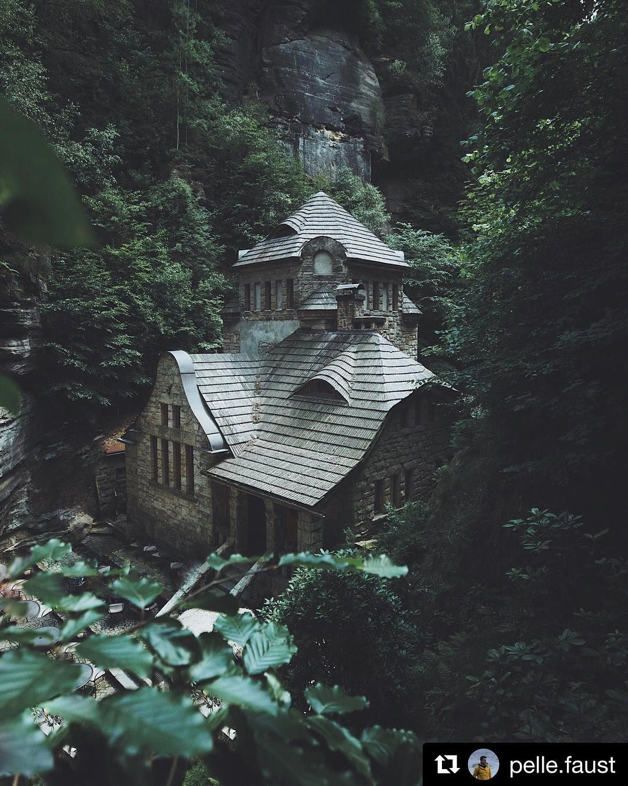

Figure 1-Outside of the cabin

# Reference

## Environment

|  |  |  |
| --- | --- | --- |
| Foggy Mountain Forest - Stock Photos | Motion Array  Figure 2 - The mountain that towers over the cabin | | |
| There's a Real-Life Enchanted Forest and It's In Dartmoor, England »  TwistedSifter  Figure 3 - The forest surrounding the cabin and mountain | A Dream of an Encounter | Magical places, Abandoned places, Landscape  Figure 4 - The forest is filled with ruins of long past civilizations |  |

## Pin em Go Girl!!Setting

|  |  |
| --- | --- |
| The Hobbit: The road goes ever on  Figure 5 - The world is high fantasy taking inspiration from middle earth | 20 Pics Of Abandoned Witch Cottages That'll Make Your Inner Witch Happy  Figure 6 - The housing is very rustic and storybook |
| 47 best images about Witch room on Pinterest | Witch room, Wood ... | Scary  halloween decorations, Halloween decorations indoor, Halloween decorations  Figure 7 - With all the beauty there is a creepy dark magic side to the world | Figure 8 - The forest surrounding the cabin is enchanted to look more welcoming than what it is |
| Figure 9 - Magic exists in this world but corrupts those who use it | |

## Characters

|  |  |  |  |
| --- | --- | --- | --- |
| Figure 10 - A witch being hunted by a witch hunter | | Cats and Witches: A Magical History | The Alchemist's KitchenFigure 11 - A witch with her familiar(s) | |
| Figure 12 - The witch of the woods  Marigold Le Fae | No photo description available.  Figure 13 - Marigolds familiar Flora | | Witch Hunter by cwalton73 on DeviantArt  Figure 14 – The serious and stubborn witch hunter |

## Features

|  |  |
| --- | --- |
| Garden in the forest, a secret garden sanctuary with flowers and veggies | Forest  garden, Secret garden, Dream garden  Figure 15 - The garden outside the cabin which grows herbs that marigold uses | Creating a Stylized Witch Hut Interior in UE4  Figure 16 - The furnishing of the main area makes it look like a standard rustic cabin |
| Witch Alchemy Room by FauxH0und on DeviantArt  Figure 17 - Inside the mountain that backs the cabin holds the witches alchemy area where she does her potion making and magic | The Wizards Chamber  Figure 18 - Panic Room using the walls of the mountain, this room was here way before Marigold settled down, but she has repurposed it into a safe room |
| A Witch's Strange and Cozy Library : r/ac_newhorizons  Figure 19 - Marigolds library filled with books on rituals, plants, and various collected texts | |

## TumblrStyle

|  |  |
| --- | --- |
| Lord of the Rings: The Rings of Power - Why Fandom Has To Embrace Change |  Den of Geek | When Dungeons & Dragons Set Off a 'Moral Panic' - The New York Times |
| Figure 20 - The inspiration was the world design of dungeons and dragons/lord of the rings and the whole style was of the cottagecore aesthetic just with some added dark fantasy elements | |

# Program

The way I will represent the 5 beats is that the player will play through the level as normal learning through interacting with their space who they are playing and what they do in that world. Until the player gets attacked by witch hunters being forced into the panic room built into the mountain the cabin backs. They will need to use their magic and potions stocked to deter the witch hunters and stay safe even though you were consuming the souls of the travelers, but it is just witch things. Your goal and reward is stay safe and maybe use the strong souls of the witch hunters so you don’t need to keep picking off travelers.

## Rooms and features

* The house is built against an abandoned dungeon within a mountain
* The garden that grows herbs and some easy to take care vegetables
* The main room, which is where marigold eats, makes food, lure travelers with the calming aesthetic and just relax
* There are two side rooms both are bedrooms one that Marigold uses and the other for travelers who need it
* Against the backwall is a bookcase that when moved reveals the entrance to the dungeon which has been repurposed for marigolds needs
* Within the hidden space is a alchemy/ritual room where marigold casts her rituals and makes potions
* There is a small library that holds books needed for marigolds rituals
* A small room that can be locked from the inside and has some port holes that can see rooms in the cabin which marigold refers to as her panic room